[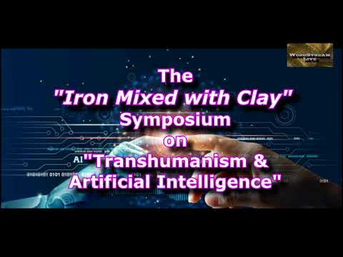](https://www.youtube.com/embed/-forJWs8vBM?feature=oembed)

What it is?

A two-day event that will cover the “Transhumanism Movement” that has taken shape in many parts of the World by a group of Futurists and Globalists who have a common goal of utilizing *technology*, what we have deemed the “Iron” **mixed** with *humanity*, the “clay,” all to create a better human being than God has created. A post human “Cyborg” that can live forever, with superior longevity, superior intelligence, superior well-being, & superior strength.

This movement is utilizing Ai and Machine Learning, Genetic Micro and Biotechnology, Robotics & Drones, and Nanotechnology as its four foundational pillars to help achieve its goals.

The purpose of this “Symposium” is to educate the body of Christ as to these technologies that not only ***will*** affect each one of us but are in fact ***already is*** doing so and most are not even aware!

Additionally, what are the Biblical and ethical considerations that every Christian needs to be considering as we move forward in these end times.

The multimedia event is hosted by keynote technology Speaker & Pastor Scott Grimm, who stays abreast of the latest technologies and their potential use and threats for the flock. He is accompanied by Pastor Jim Harper, who will be delivering several key messages on the Church’s role in the end times. Also, Pastor Howard Carpenter will be joining us from Pittsburg, Pa. to deliver several key expositional lectures on the correlation of Bible prophesies on these important matters. Lastly, Dr. Richard Roiger, who has an extensive background in Ai and Machine Learning will be sharing valuable insights on these very significant technologies.

To register please email Pastor Scott Grimm @scottgrimm24@gmail.com or call or text 239-677-9260. Additionally, there is a sign-up sheet located at the sound booth at the Church as well. Seating is limited to 60 guests and is on a first come (register) basis. Refreshments, and continental breakfast and lunch will be provided for a love offering donation of any amount.